# **Analysis of the 5G Smartphone Market in India’s Mobile Phone Industry Using Python**

**BY BAMISAYE PIOUS ALEXANDER**

**Introduction**

The rise of **5G technology** is transforming India's mobile phone industry. As **telecom providers expand network coverage**, smartphone manufacturers are striving to gain market share by offering **innovative features, competitive pricing, and performance-driven enhancements**. This surge in **5G smartphone adoption** is reshaping consumer preferences and purchasing decisions, influenced by **brand reputation, price, storage, camera quality, battery life, and processing power.**

This project leverages **Python-based data analysis** to examine **India’s 5G smartphone market,** providing key insightsinto **pricing structures, brand influence, and feature preferences.** Using **Pandas, NumPy, Matplotlib, and Seaborn,** the study visualizes data through **bar charts, scatter plots, correlation heatmaps, and pie charts**. These insights will aid **manufacturers, telecom providers, and policymakers** in making **data-driven decisions** in this evolving market.

### ****Significance of 5G Adoption****

The rollout of **5G networks** has introduced **higher internet speeds, lower latency, and improved efficiency**, driving greater consumer demand for **5G-enabled smartphones**. This makes it crucial for manufacturers to balance **affordability, performance, and cutting-edge features** to meet market expectations.

### ****Purpose of This Analysis****

As competition intensifies, it is essential to analyze:

* **Pricing variations** across premium, mid-range, and budget 5G smartphones.
* **Consumer priorities** in terms of camera quality, battery life, and processing power.
* **Market dominance** among leading smartphone brands and identifying weaker players.

By conducting this **data-driven study,** we aim to uncover critical insights that can shape strategic decisions in India's **rapidly expanding 5G smartphone market.**

## ****Dataset Overview****

To analyze the Indian 5G smartphone market, **real-world data was scraped from MySmartPrice (mysmartprice.com),** a popular Indian website providing information on smartphone specifications, pricing, and feature comparisons.

### ****Dataset Composition****

The dataset contains **959 rows and 10 columns**, representing different **5G smartphone models** and their key specifications. The columns include:

* **Model** – The smartphone’s name.
* **Brand** – Manufacturer of the smartphone.
* **Screen Size** – Display size (in inches).
* **Front Camera** – Resolution of the front-facing camera (MP).
* **Back Camera** – Resolution of the rear camera(s) (MP).
* **Battery Capacity** – Battery size (mAh).
* **ROM** – Internal storage capacity (GB).
* **RAM** – Random-access memory (GB).
* **Clock Speed** – Processor speed (GHz).
* **Price** – Smartphone price (in Indian Rupees, INR).

This dataset serves as the foundation for **analyzing brand influence, feature popularity, and pricing variations** in India’s 5G smartphone market.

## ****Data Cleaning Process****

Data cleaning was an essential step to ensure accuracy and consistency for effective analysis. The following preprocessing steps were performed:

1. **Handling Missing Values** – Missing values were identified and either filled or removed, depending on their significance in the dataset.
2. **Checking Data Types** – Ensured all numerical values (e.g., price, RAM, ROM, battery) were correctly formatted.
3. **Removing Duplicates** – Eliminated duplicate entries to avoid skewed insights.
4. **Correcting Spelling Errors** – Standardized brand names and feature labels.
5. **Identifying and Treating Outliers** –
   * Premium brands like **Apple and Samsung** were identified as valid high-priced data points rather than statistical errors.
   * Other extreme values were analyzed for potential data entry mistakes.

With the dataset cleaned, an **exploratory data analysis (EDA)** was conducted to extract key insights.

## ****Result Findings & Insights****

### ****4.1 Brand Pricing Trends****

To understand price variations across brands, a **bar chart was** created to visualize the **average price of 5G smartphones by brand.**

**Key Insights:**

* **Apple’s 5G smartphones are the most expensive**, reinforcing its position as a **luxury brand** with strong brand loyalty.
* **Lava offers the cheapest 5G smartphones**, catering to budget-conscious consumers.
* **Brand popularity creates significant price gaps** – Premium brands (Apple, Samsung, OnePlus) charge higher prices, while mid-range brands (Realme, Vivo, Xiaomi) balance affordability and performance.

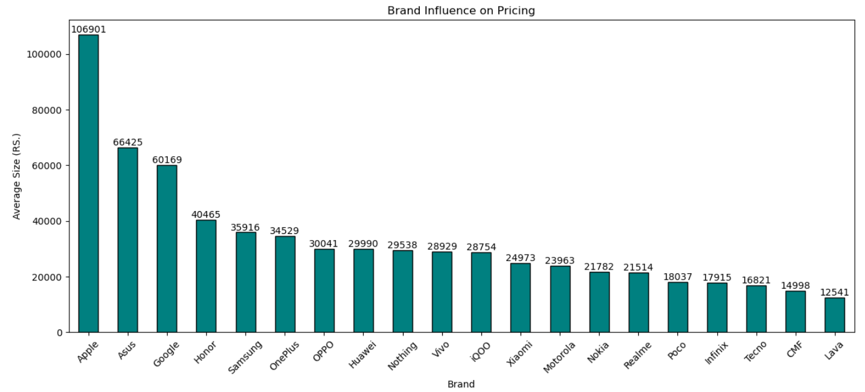

### ****4.2 Screen Size vs. Price****

A **scatter plot** was used to analyze the relationship between **screen size and price.**

**Key Insights:**

* **No strong correlation between screen size and price** – Larger screens do not necessarily indicate higher prices.
* Most smartphones fall within the **6.0 - 6.8 inches range**, but their prices vary significantly from **budget to premium models**.
* **Screen quality (e.g., AMOLED, refresh rate, resolution)** likely impacts pricing more than size alone.

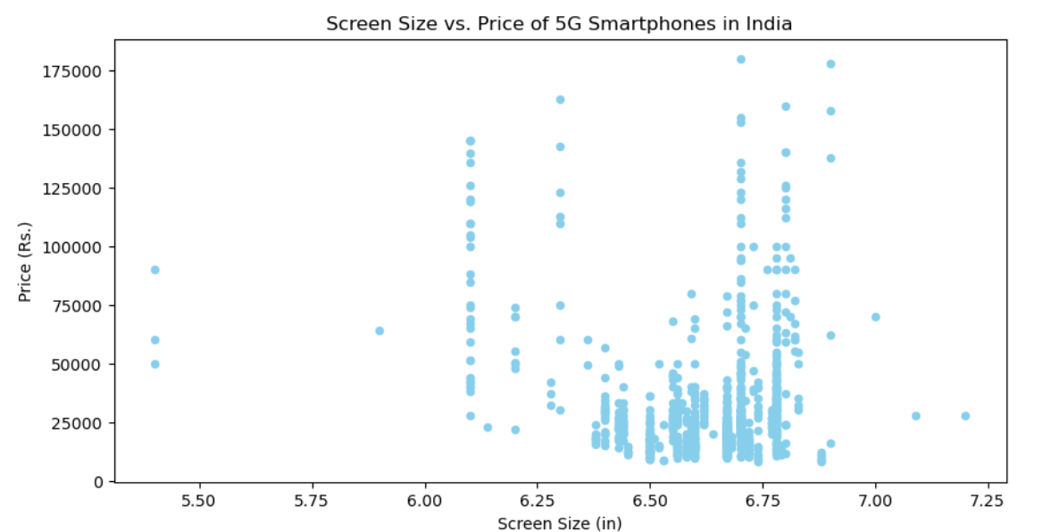

### ****4.3 Most Preferred Back Camera Configuration****

A **bar chart** visualized **the most popular back camera megapixel (MP) configurations** among 5G smartphones.

**Key Insights:**

* **50MP cameras dominate** the market, followed by **64MP and 48MP sensors**.
* **Ultra-high MP cameras (160MP and above) are rare**, likely due to **cost concerns and diminishing returns in image quality.**
* **Consumers prioritize camera quality over just megapixels**, as factors like **sensor size, AI processing, and lens quality** matter more.

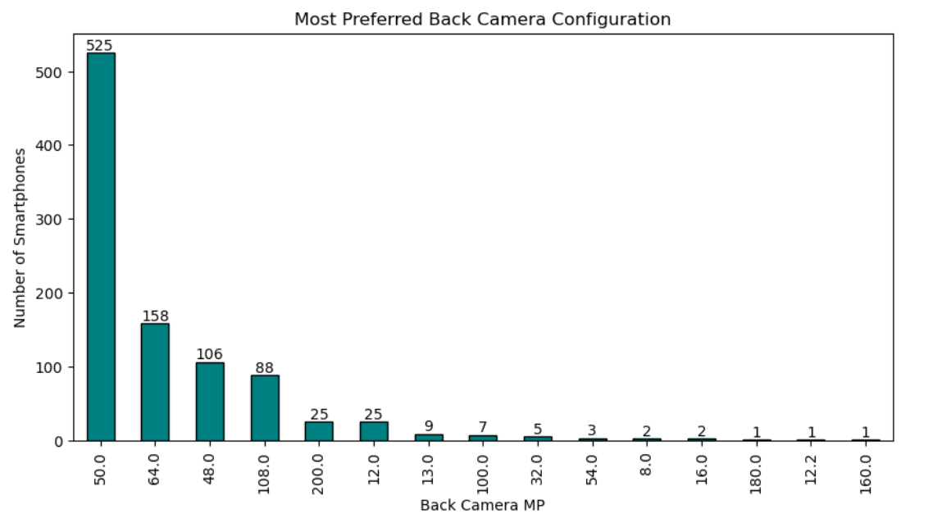

### ****4.4 Market Share of Top 5 5G Smartphone Brands in India****

A **pie chart** analyzed the **market share distribution** among India’s top **5G smartphone brands.**

**Key Insights:**

* **Realme dominates the Indian 5G market**, reflecting **high consumer demand** for its affordable 5G models.
* **Samsung, Vivo, and Xiaomi maintain strong competition**, securing major portions of the market.
* **Huawei holds the smallest market share**, indicating **weaker brand presence in India**.

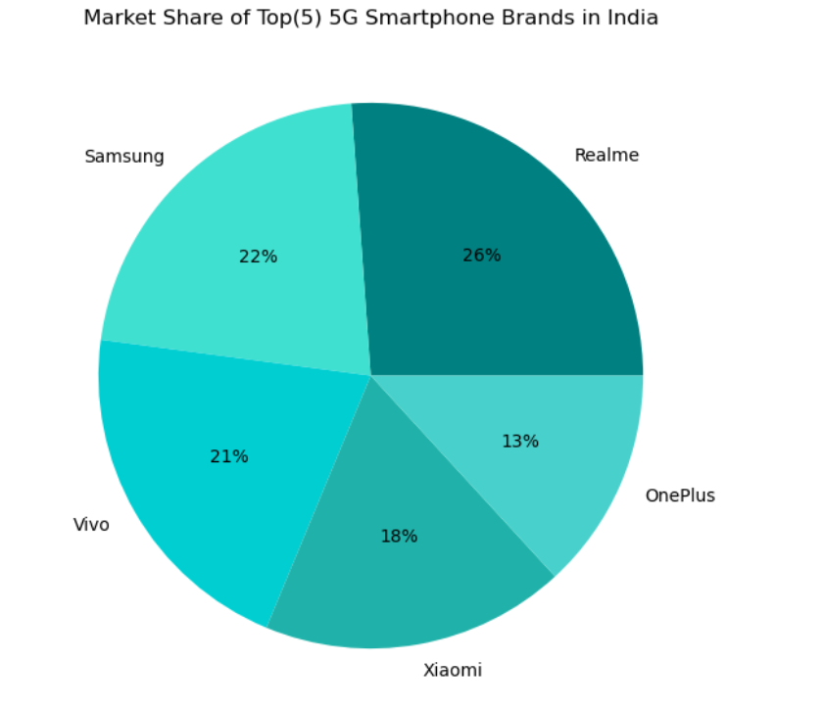

### ****4.5 Correlation Heatmap: RAM, ROM, Battery, and Price****

A **correlation heatmap** was generated to identify relationships between key specifications and pricing.

**Key Insights:**

* **Storage (ROM) has the highest impact on price**, as consumers prefer higher storage options.
* **Battery capacity has little to no influence on price**, suggesting that most brands standardize battery sizes.
* **High RAM and ROM combinations are common in premium models**, indicating that storage and performance are major selling points.

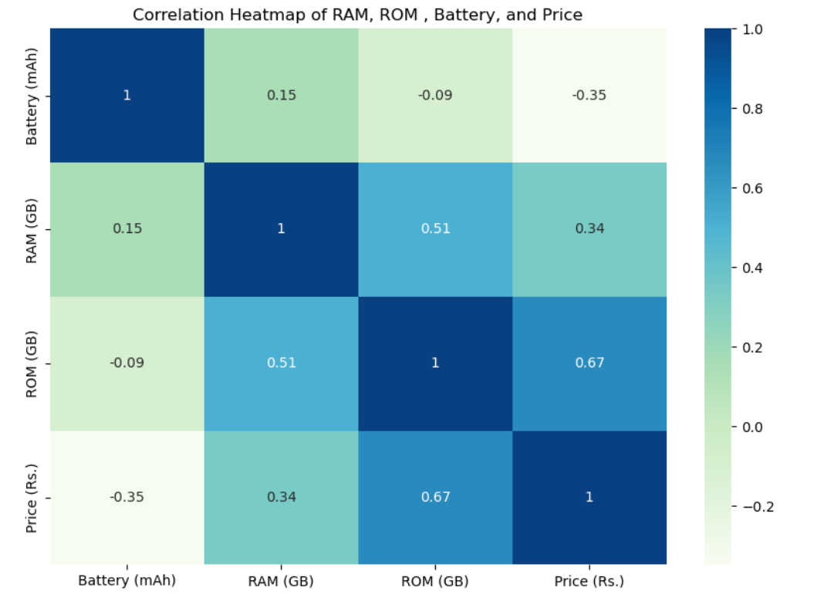

### ****4.6 Clock Speed Distribution in 5G Smartphones****

A **bar chart** examined **clock speed distribution** among 5G smartphones.

**Key Insights:**

* Most devices operate within **2.0 - 2.5 GHz**, ensuring a balance between **performance and power efficiency.**
* **Higher clock speeds (above 3.0 GHz) are uncommon**, mainly found in premium gaming and flagship models.

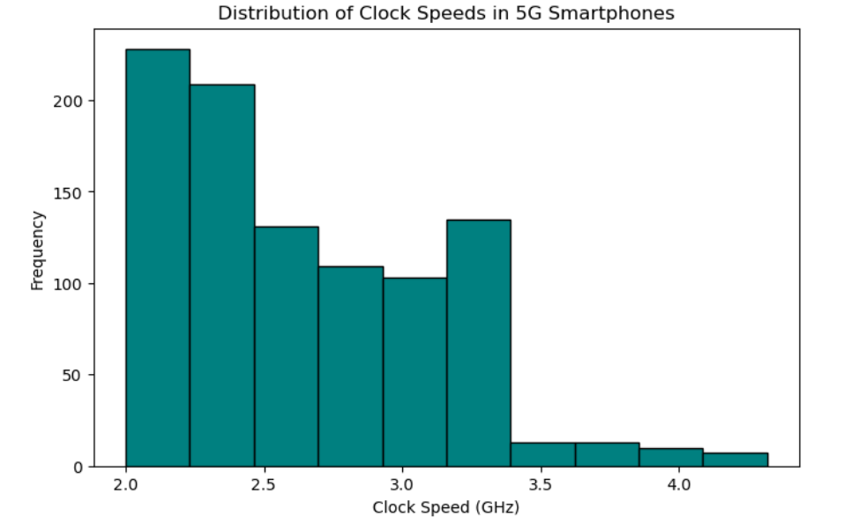

### ****4.7 Battery Capacity Distribution****

A **bar chart** visualized how **battery capacities vary across 5G smartphones.**

**Key Insights:**

* **4500 - 5499 mAh batteries are the most common**, ensuring **longer battery life for most 5G smartphones.**
* **Very high battery capacities (5500 - 6500 mAh) are rare**, likely due to weight and size trade-offs.

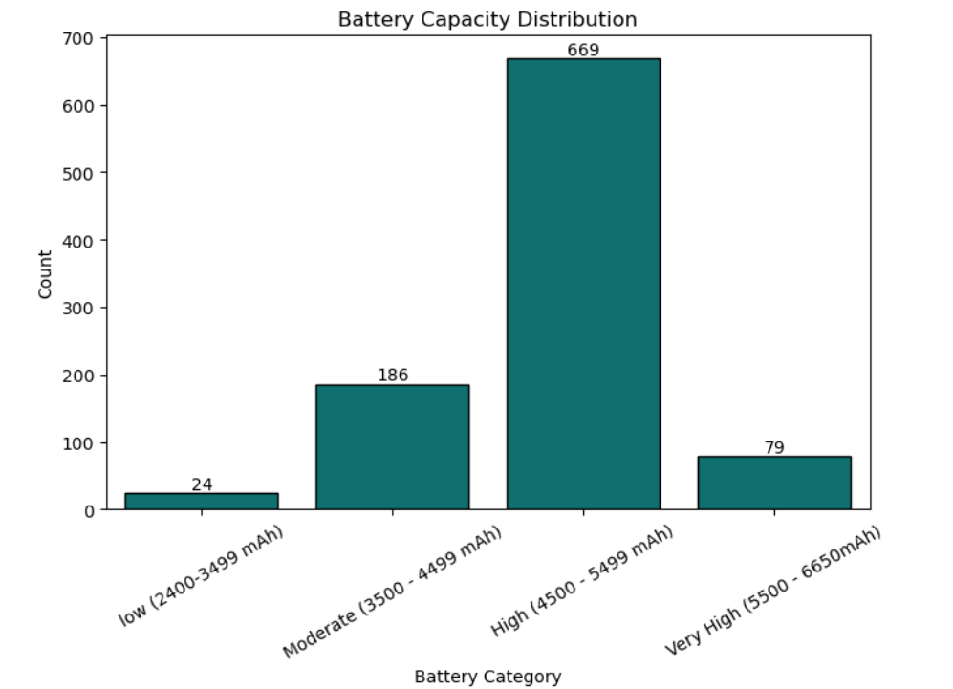

**Recommendations**

Based on the insights derived from the analysis, the following recommendations are proposed for **manufacturers, telecom providers, and policymakers** to enhance the growth and competitiveness of India’s 5G smartphone market.

**5.1 Expand Affordable 5G Smartphone Options**

Since Lava offers the most affordable 5G smartphones, other brands should explore **low-cost 5G models** to capture a larger market share. Expanding budget-friendly 5G options will accelerate 5G adoption in India’s price-sensitive market, especially in rural and semi-urban areas.

**5.2 Prioritize Storage (ROM) in Pricing Strategies**

As ROM (internal storage) has the highest correlation with price, brands should offer multiple storage configurations (128GB, 256GB, 512GB) at different price points. Consumers prioritize **storage space**, especially for media and gaming, making it a crucial factor in purchase decisions.

**5.3 Optimize Camera Technology in Mid-Range Models**

The market favors 50MP, 64MP, and 48MP cameras, meaning manufacturers should focus on enhancing image processing and AI-powered photography rather than just increasing megapixels. Ultra-high MP configurations (160MP and above) remain niche, suggesting that camera performance matters more than resolution alone.

**5.4 Strengthen Realme’s Market Position & Improve Huawei’s Share**

* **Realme should maintain its strong market position** by offering feature-rich 5G devices with competitive pricing.
* **Huawei needs to reassess its market strategy** by investing in brand visibility, partnerships, and local manufacturing to gain traction in India.

**5.5 Balance Screen Size and Display Quality**

Since screen size does not strongly impact pricing, brands should focus on improving display quality (AMOLED, higher refresh rates, HDR support) rather than increasing screen size. Consumers value display technology over size alone.

**5.6 Enhance Battery Efficiency Instead of Capacity**

While 4500 - 5499 mAh batteries are the most common, simply increasing battery capacity is not the best solution. Manufacturers should focus on:

* **Power-efficient processors** (e.g., Snapdragon 8 Gen series, MediaTek Dimensity).
* **AI-driven battery optimization** for better power management.
* **Fast-charging technology** to compensate for moderate battery sizes.

**5.7 Introduce High-Performance Models for Power Users**

Since most 5G smartphones operate within 2.0 - 2.5 GHz, brands should introduce higher clock-speed models (above 3.0 GHz) for gaming and professional users. Gaming smartphones could be a potential growth segment with optimized cooling systems and high refresh rate displays.

**5.8 Improve Marketing Strategies for Niche Camera Models**

Manufacturers should focus on better marketing for ultra-high MP cameras (160MP and above) by showcasing real-world advantages like zoom capabilities, low-light performance, and AI enhancements to justify premium pricing.

**5.9 Expand Market Reach to Rural Areas**

Since budget-friendly 5G models can drive wider adoption, brands should:

* Strengthen offline retail and partnerships in rural and semi-urban areas.
* Offer affordable financing options to make 5G devices more accessible.
* Collaborate with telecom providers to promote bundled 5G smartphone plans.

**5.10 Develop AI-Powered Software Optimization**

Instead of focusing solely on hardware improvements, brands should invest in software-driven optimizations like:

* AI-based camera enhancements for better image quality.
* AI-powered battery management for longer screen-on time.
* Performance optimization through machine learning for smooth multitasking.

By implementing these strategies, manufacturers can stay competitive, drive innovation, and meet consumer demand in India's growing 5G smartphone market.

**Conclusion**

The Indian 5G smartphone market is highly competitive, with Realme leading in market share while Huawei has the smallest presence. Pricing strategies are heavily influenced by storage (ROM), while battery capacity has minimal impact on cost. Most 5G smartphones operate within 2.0 - 2.5 GHz and feature 4500 - 5499 mAh batteries, balancing performance and power efficiency.

To stay ahead in the market, brands must focus on:

* **Expanding affordable 5G models** to reach a broader audience.
* **Prioritizing storage options** as a key pricing factor.
* **Enhancing display quality and battery efficiency** instead of just increasing screen size or capacity.
* **Strengthening AI-powered optimizations** for better user experience.

As India’s 5G adoption grows, manufacturers who adapt to consumer preferences, performance trends, and market demands will lead the next phase of smartphone innovation.